ME 423 Engineering Design VII

Phase 1 – Proposal and Conceptual Design

**3D Printed Granular Jamming Hand**

**A Senior Report**

**Group #37:**

Melissa Indoe

Seoungwoo Kang

Sean Phelan

Maggie Serra

Chris Wallace

**Advisors:**

Robert Chang

Jennifer Field

**STEVENS INSTITUTE OF TECHNOLOGY**

Castle Point On Hudson

Hoboken NJ 07030

(September 2013)

**3D Printed Granular Jamming Hand**

# Abstract

An open-source and mainly 3-D printable hand prosthesis is to be developed by a team of five Mechanical Engineering seniors in a student-driven design project. The hand prosthesis will combine the technologies of existing 3-D printed hands with the concept of granular jamming to maintain a firm grip at a fraction of the cost of existing prostheses. The hand will allow for performance of relatively low strength, high dexterity, household tasks. To meet this goal, a background on types and incidences of amputation has been established, as well as on state-of-the-art designs in both professional and hobbyist prostheses. Potential users of the product have been identified, and some original research on hand usage has already been completed. Additionally, conceptual designs have been generated and compared, resulting in a generalized plan for future hand design and a plan for future testing and development has been generated.

**Authors:** Melissa Indoe, Seoungwoo Kang, Sean Phelan, Maggie Serra and Chris Wallace

**Advisors:** Robert Chang and Jennifer Field

**Department:** The Department of Mechanical Engineering

Table of Contents

Abstract 2

Introduction 4

Project Objective 4

Project Background 5

Problem Statement 5

Societal Impact 5

State of the Art and Existing Designs 6

Conceptual Designs 9

Features and Comparisons of Conceptual Designs 15

Technical Analysis and Engineering Design 20

Deliverables for End of Semester 22

Expected Budget 23

Project Schedule 24

Summary and Conclusion 25

Nugget Chart 26

References 28

Appendices 30

Appendix 1: Granular Jamming Pictorial Explanation 30

Appendix 2: Goal size for prosthetic hand 32

Appendix 3: Preliminary Testing with Chalk 34

# Introduction

## Project Objective

The objective of this project is to create an open-source, affordable, and high-functioning prosthetic hand. The hand should be task-oriented and able to perform household activities requiring relatively low strength and high dexterity. It should be similar in size and weight to a human hand, and look relatively similar as well, to make it appear relatable and human (since one major issue with some of the more common prosthetics is that their appearance is often alienating to the user). Since there are already some very effective finger and partial hand prosthetics on the market, this prosthetic will be designed for users who have lost their hand and some or most of their forearm. From there it would also be relatively simple to design for more of the arm, such as the elbow or shoulder (not within the scope of this project, but being open source, someone else could certainly pick up that torch). The major issues involved in creating this mechanical hand are maintaining dexterity of the fingers, maintaining device durability, and making the device affordable and available to anyone.

Primary task goals are as follows. Firstly, the hand should be able to pick up and put down objects of varying sizes and shapes. It should also be able to open and close doors of varying types, such as lever style doors, knob style doors, and refrigerator doors. To maintain some level of comparability (and avoid venturing too far into the uncanny valley), it should be able to perform simple gestures such as pointing, or giving a “thumbs-up” gesture. It should also be able to use a computer mouse. Computers have become an immensely important facet of society, and while a keyboard would prove too complex given the budget and timeframe, a mouse can certainly be used to perform most computer-based tasks (especially when paired with existing software meant to facilitate typing with the mouse). Finally, the hand should be able to use occupational therapy tools, such as cutlery and pencils or pens. Again, while it may prove too complex to use traditional utensils, the larger size of an occupational therapy device, combined with the abilities of the hand, should offer a level of autonomy that the user would not have had otherwise. If most or all of these task goals can be completed, the project will be considered a success.

Secondary goals are slightly more complex. Some examples of secondary goals are the ability to use touchscreens (via a conductive layer on the thumb and index finger), ability to open pop-top cans, achieving rotation, primitive myoelectric control (for opening/closing of the fingers), and allowing for joint locking so that certain positions can be held while only one joint is moved (useful for certain tasks, such as using a mouse or playing a note on a keyboard). If some or any of these goals can be achieved, it would add significant functionality to the project, however, these goals are not a priority, but are instead seen as a way to move the project forward if primary goals have already been achieved.

## Project Background

Approximately 12,500 new arm amputations occur in the US every year, with the vast majority (77%) occurring due to trauma (Kulley).The type of arm amputations may vary (forequarter amputation—at the shoulder, transhumeral—above the elbow, transradial—below the elbow, etc), but transradial amputations are the most common, with an incidence of about 44% (Freeland). In order to help amputees, mechanical hands and arms have been developed, and have existed for years. These hands are operated by cables attached to the shoulder and control grasp by shrugging. Unfortunately these devices make inaccurate motions, do not grasp irregularly shaped objects well, are uncomfortable, and are expensive. More modern prosthetic hands controlled by myoelectric sensors have existed for the last 5-10 years. However these prosthetics are very expensive and heavy, weighing 2-3 times as much as hook and cable arms and costing $11,000 at the low end, which often is not covered by insurance.

Additionally, amputation is a global problem and many groups, especially those in developing countries, do not have access to even simplistic prosthetics. In fact, it is estimated that only half of all arm amputees ever get access to prosthetics (Kulley). Therefore, individuals in developing countries can often be left handicapped and with no access to help.

This project is designed to overcome some limitations of these commercially available prostheses. This hand will be 3-D printed, lowering both cost and weight. It will combine a relatively simple control system (five motor/encoder setups and no additional sensors) with granular jamming pads that form around the objects being manipulated. This combination should be able to provide a low-cost alternative for the more cutting-edge myoelectric hands, sacrificing some freedom and complex control without greatly effecting usability, due to the added functionality of the granular pads. Additionally, the hand will be made available for public use as open source, so anyone with access to a 3-D printer can print out his or her own device. This means that, rather than requiring expensive centralized manufacturing and shipping costs, hands could easily be made anywhere at any time (and be customized for the user with a few edits of the source code), opening up many possibilities for humanitarian aid.

## Problem Statement

Thousands of arm amputations happen each year around the world and loss of an arm can severely limit the independence of an amputee. There are current prosthetics that restore functionality to the missing limb of the amputee, but they are not available to many people globally due to cost and availability. Therefore there is a need to create an inexpensive and readily available prosthetic for amputees around the world.

## Societal Impact

This design project has a potentially huge impact on people living with limb loss. There are around 12,500 arm amputations per year just in the US, and extremely limited data on amputation worldwide, due to lack of reports from developing countries. One estimate places the number at about 3 million arm amputees worldwide (LeBlanc), with 1.4 million people living as below-elbow amputees in developing countries.

Our project aims to create a lightweight, inexpensive, easily created robotic arm, which should be able to improve the quality-of-life for many of these amputees. If the cost is low enough, the prosthetic arm could be used in war torn countries like Afghanistan, Syria and Libya where many civilians are injured by IEDs or implanted mines. All that would be required for humanitarian groups is a 3-D printer, which can cost as little as $2000, raw plastic, costing approximately $27/kg, motors, vacuums, and assorted fittings. Even the granular jamming pads can be filled with materials as simple and ubiquitous as coffee grounds and sawdust. After investing in the sunk cost of the printer, groups could travel abroad, able to carry their printer, plastic, and other miscellaneous parts, buying some of the more common materials locally. This means that the hand would have essentially no manufacturing costs beyond the materials and the time needed to run the printer. Rather than requiring user data (stump size, prosthetic needs, etc) to be sent to a site capable of complex molding, machining, etc and then shipping the result out on a case-by-case need, hands could be customized and manufactured on the spot, greatly reducing overhead (since no shipping costs would be required, nor would shop space or shop employees). This has quite profound implications for amputees worldwide.

The limb can also be used for our own soldiers returning from war or for veterans that have not previously been able to afford the current prosthetic limbs. Since this hand design will be so inexpensive and easy to customize, it can even be used as an occupational therapy tool while these soldiers are waiting on more advanced prosthetic arms. The hand can also be used in many hazardous situations including the handling of hazardous materials, caring for babies in incubators, and in the manufacturing and automation industry, or it can be used as a development platform for anyone looking to experiment with modifying or programming their own prosthetics. Because of all of these interesting and varied applications, our design is going to be made on an open source CAD program so that anyone can download, edit, or improve the project for free. The team strongly believes that this design should not just die with the project, but instead should be available to anyone who takes interest in it.

# State of the Art and Existing Designs

In this section we will discuss a state of the art design manufactured by a medical technology company as well as designs made by laypeople. Medical device companies have the resources to design prosthetics that can be approved for human use. Our focus will be on simpler existing open-source models not meant as prosthetics, which are more easy to make and affordable.

Medical device companies have made great strides in the prosthesis field. One such company is RSLSteeper. This company has created the bebionic hand, a myoelectric prosthesis. The most current product, the bebionic3, uses sensors placed on the skin to pick up impulses from muscle tissue to control the hand. It has individual motors for each finger which are positioned to optimize weight distribution. The hand features proportional speed control so the hand can perform delicate tasks as well as handling up to 45 kilograms. The prosthesis is designed to mimic a human hand and move as naturally as possible. The bebionic3 is one of several state-of-the-art prosthetics on the market today. It costs about $11,000. Others include the iLimb by touch bionics, costing about $100,000 and the Michelangelo by Ottobock, costing about $74,000. The iLimb and Michelangelo use similar technology to the bebionic3.

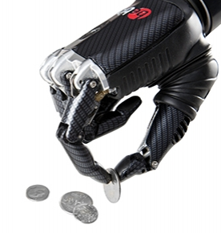

Figure 1: bebionic hand

The bebionic3, as well as the iLimb and Michelangelo, represent the absolute cutting-edge in prosthetics and can provide most of the degrees of freedom of a human hand. However, in some respects they are also over-engineered and they are virtually unavailable to those without access through health insurance, due to their cost. They are also not at all a viable solution to amputation in developing countries, due to their price and complexity. Therefore it becomes necessary to explore other simpler hand prosthetic solutions. Therefore, we will next discuss hands made by laypeople. These hands were designed and manufactured by people with limited resources. Because of that, they are simple and affordable; setting a precedent for inexpensive 3D printed hands.

The first of these hands, the RoboHand, was designed by Richard Van As, a man from South Africa who lost his fingers in an industrial accident. He used a MakerBot 3D printer and created the design on CAD software. The entire assembly is composed of 3D printed parts, with the exception of three components: the cables, the metal fittings, and the thermoplastic used to secure the device around the user’s arm. The hand has a very simplistic design using a system of cables. When the user bends his wrist down, the cables effectively shorten, causing the fingers to curl into a grasping position. When the user bends his wrist back up, the hand opens and the fingers release. Although the hand is not medically sanctioned, Richard has used this design to help children suffering from amniotic band syndrome.

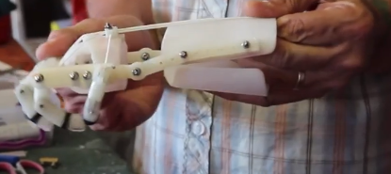

Figure 2: Wrist bent down, fingers grasping.

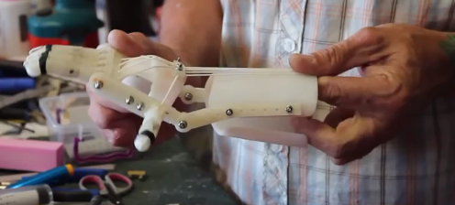

Figure 3: Wrist bent up, grip released.

Another hand created using a 3D printer is called the InMoov. This is a robotic hand and was not meant as a prosthetic. The hand moves using motors attached to cables on the inside and outside of each finger. When the motor tightens the cables on the inside, the fingers curl in. When the motor releases the inside cables and tightens the cables on the outside, the fingers open. The device can be controlled using electrodes attached to the skin which pick up impulses from the muscles, much the like the bebionic3. When the user opens and closes his hand, the robot mimics his actions. Examples of this can be seen in the following images.

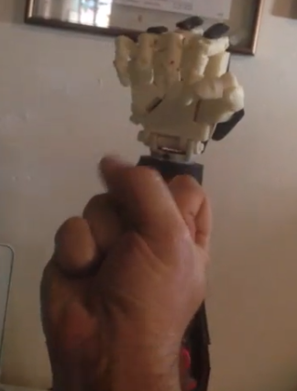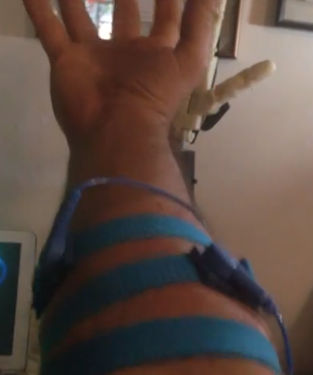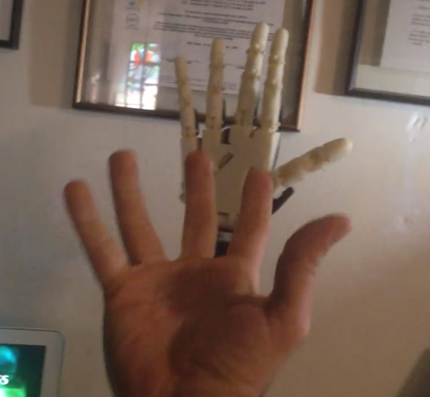

Figures 4, 5, 6 (from left to right): Electrodes are attached to the users arm. Robot closes fist when user closes fist. Robot opens hand when user opens hand.

The other major aspect of the granular jamming hand is, naturally, the concept of granular jamming. Put simply, granular jamming is an emergent field based around the fact that granular material (coffee grounds, diatomaceous earth, glass beads, etc) will enter a “jamming” transition when pressure is added (usually by applying a vacuum force). This jamming behavior has only been studied very recently, and was proposed as a new kind of phase transition in 2007 (Biroli). Many factors influence effective jamming, namely the shape, deformability, frictional force, and packed density of the particles. Surprisingly the granular material with the greatest strength-to-weight ratio found so far is fine-ground coffee; it is hypothesized that this is because of its rough surface, which increases friction, and because of the moisture it contains (Cheng). Currently the practical applications of this are just starting to be discovered.

Granular jamming is integral to this project because it is an extremely effective way to manipulate objects. Actions that are difficult for traditional grippers, or even humans, are comparatively easy to accomplish with granular jamming. For example, a balloon can be filled with coffee grounds, attached to a vacuum, and then pressed around household objects such as eggs, pens, and flat coins (something that can even be difficult for a human to pick up), and once the air is removed it molds completely around that object and maintains a firm grip. The one cable per finger design makes the hand much less dexterous than modern motor-driven prosthetics, but this granular jamming can more than make up for its limited range of motion with the pliability of the granular jamming pads. These jamming pads would improve grip during grasping activities (such as opening doors or picking up a glass of water) but would also allow problems to be approached in totally new ways. For example, rather than grasping delicate things with the fingers and potentially crushing them (one unfortunate limitation of having a hand with no sensors), the user could just gently press their palm on the object and then activate the vacuum to grasp it. A pictorial explanation of granular jamming is included in Appendix 1.

# Conceptual Designs

To simplify the design process, conceptual design ideas were split into three categories: hand ideas, which related to the rigid 3-D printed components of the hand; granular jamming ideas, which related to the soft granular jamming pads and accompanying pneumatic assembly; and other considerations, which acted as a catch-all grouping for ideas which were valuable, but did not fit into the other two categories.

In the hand ideas category, methods were considered for the four subcategories: moving joints, holding position, straightening the hand, and sensing grip. For moving joints, pneumatics, motors at each joint, and cabling systems were all considered.

Pneumatics would consist of a pneumatic muscle tube that, when filled with air, would effectively shorten and pull on the fingers. This idea was considered because it is an emergent technology modeling human motion. Therefore it would have been realistic and interesting, and also could have utilized the same pneumatic system as the granular jamming pads.

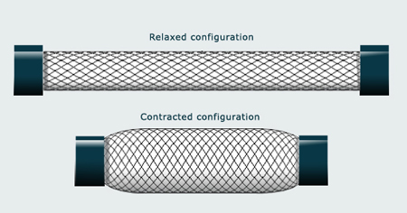

Figure 7: Pneumatic Muscle example. Filling the muscle with air causes it to contract, getting larger in diameter and decreasing in length. This would be attached to a cabling system which would then pull the fingers inward.

Motors at each joint were considered because they are what is used by state-of-the-art prosthetics, such as the bebionic3. This idea would consist of placing one motor at each joint in each finger. It offers an unprecedented range of motion, but is also very complex.

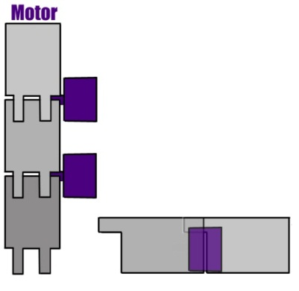

Figure 8: Motor System example. Each joint is run by an individual motor, allowing for a full range of motion.

The cabling system was considered because it is the state-of-the-art for current open-source hands. Therefore it is a proven technology in the field that the team will be operating in. For this design, cables would be run along the underside of each finger, up to motors in the arm. Running the motor would wind up and effectively shorten the cables, bringing about a downward force at the finger hinges, drawing them inward toward the palm.

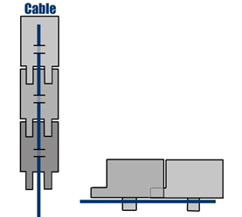

Figure 9: Cabling System example. The cable runs along the underside of the finger, which hinges near the center. Pulling on the cable generates a downward force and pulls the finger inward uniformly to the palm. These cables can be attached to either pneumatic muscles or to motors housed in the forearm.

An additional permutation was also considered, combining motors at the base of the fingers with cables running along their lengths. This would add some dexterity and allow for only the joint at the base of the finger to be moved. All of these technologies had unique merits and shortcomings, which will be discussed more in-depth during features and comparisons.

To hold joints static, it was considered if, firstly, it was important enough to warrant spending time and resources designing around static joint options, and secondly, how to do it. The ideas of gear teeth at joint interfaces and external joint locks were both considered.

To straighten the hand, the ideas of using long elastics, short elastics (at joints only), flat springs, and opposing cables were all explored. Long elastics appeared most like the human hand, closely modeling the extensor tendons found along the back of the finger. This made them one of the more relatable options and made the hand look more real. They also offered a fairly realistic range of motion, with the exception that extensor tendons are not always active, but instead can be straightened and relaxed. Conversely, the elastics would always be active unless counteracted by the finger bending, meaning that the resting position of the fingers would be straight. One other aspect of this design is that it requires that teeth be added to the top of each finger to ensure that it is not hyperflexed in its resting state.

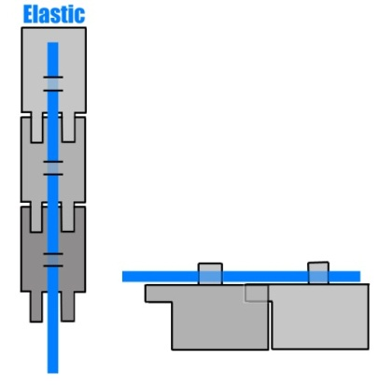

Figure 10: Long elastic example. The elastic runs along the top of the finger, opposing closing motion, and anchors on the back of the hand. When the hand is in a resting state, the fingers are straight. Teeth on the top of each finger mesh and ensure that the finger will not hyperflex when relaxed, via mechanical interference.

Short elastics utilized the same concept (pulling the joints straight and utilizing mechanical interference to avoid hyperflexion) as the long ones, while also allowing for easier replacement. They also required guards to ensure that they would stay securely on the finger, which adds another step to modeling.

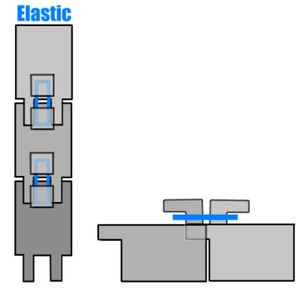

Figure 11: Short elastic example. This elastic is only present at joint interfaces, and is clipped around an outcropping that flares out to ensure that it will not slide off. Teeth on the top of each finger mesh and ensure that the fingers will not hyperflex when relaxed, via mechanical interference.

Flat springs mimicked the action of the short elastics, but did not require the same plastic structures to prevent the fingers from hyperextending, which simplifies model generation for printing. They were also a much more durable choice than the short elastics, though harder to replace (diagram on following page).

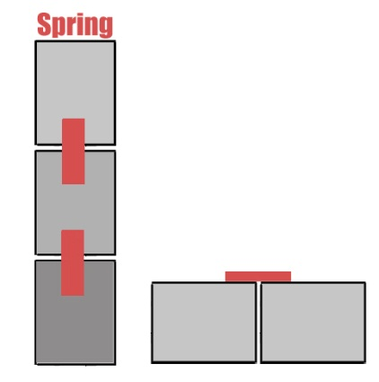

Figure 12: Flat spring example. The flat springs are thin pieces of metal that straighten out when not under force. This ensures that the resting state of the fingers will be straight. Intermeshing teeth are not necessary for this design.

Opposing cables also approximated tendons, even more accurately than the long elastics did, but required a second set of motors, and were therefore a very complex choice. The opposing cable design would simply consist of a set of cables running along the top of the finger (rather than the underside as the closing cables would). Pulling on these cables would pull the fingers upward and therefore straight. Running the two cables against each other would keep the fingers totally rigid.

To sense grip, there were three ideas considered: first, that there could be no grip sense, and instead a vacuum activated via button, second, that there would be a bump sensor under the granular jamming pads, and third, that an encoder would be paired with the servo motors to read if they had reached a stall state. The reasoning for using an encoder with the servo motors, rather than using the servos’ onboard potentiometers, is because it allows extremely inexpensive hobbyist servos (which tend to have inconsistent manufacturing tolerances) to attain a degree of accuracy that they could not have otherwise. This is very important for fine motions of the fingers. Additionally, at the scale of the motors in the hand, servos are actually more widely available and inexpensive than DC motors, and since the encoders cost around a dollar each, the redundancy, when compared to the improvement in accuracy, more than makes up for the cost.

The second category of conceptual design is granular jamming. This was also split into three subcategories: granular jamming material, housing material, and layout of the pads.

For granular jamming material, initially three options were considered: sand, coffee grounds (a material that has been previously shown to work), and plastic stuffing materials, as one would see in a weighted stuffed animal. Housing materials considered included balloons (another material that had been proven to work) and slip-cast silicone (similar to what is used in animatronics and costuming applications).

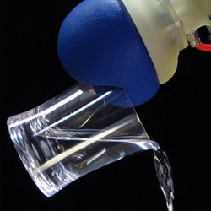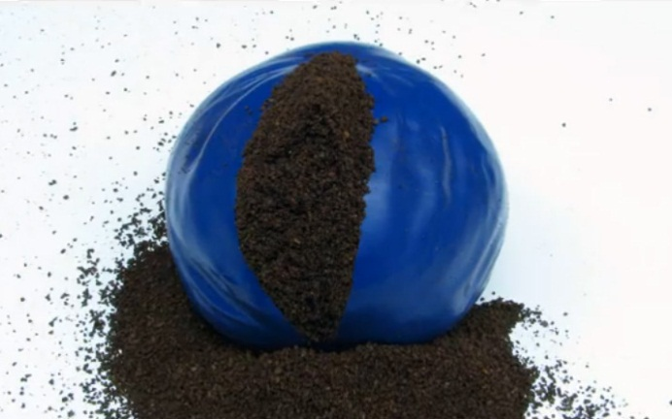

Figure 13: A granular jamming gripper can be as simple as a balloon filled with coffee grounds, as shown here.

For layout, two subcategories were considered. The first subcategory was method of connecting the pads to the vacuum. It was considered whether the pads should be interconnected, (i.e. with the fingertip pad running into the finger base pad, which itself would run into the palm) or individually connected via tubing to the vacuum main line (i.e. a line comes up from each pad, lies along the back of the hand, individually running to the wrist where the pump is located). The second subcategory was the layout and location of the pads. Designs for the layout included having pads on each fingertip and the palm, pads on the 3 sections of the finger and the palm, or having pads on two finger sections and the palm.

The third category of conceptual designs was “Other Considerations.” These were good ideas that did not fit into either hand or granular jamming categories. Ideas considered in this category included size, use with touch screens, nails, and printing the hand in polycarbonate plastic (which would add strength). Size was deemed extremely important for the project, as the hand could not be significantly smaller, larger, or heavier than a real human hand. Touch screen usage could be solved with a conductive fabric and was considered a secondary goal, as was the idea of adding prosthetic nails (which are used for certain tasks, such as opening cans).

Size for the prosthetic is actually extremely important. Wearing a prosthetic significantly heavier than the opposite arm leads to fatigue and chronic back pain, as does wearing no prosthetic at all (since humans tend to instinctively lean away from their heavier side to maintain balance). Additionally the prosthetic cannot be much larger or smaller than a human hand. Therefore goal size of the prosthetic width were determined as palm width=79mm and finger width=19.75mm. Lengths were determined as follows: L1=44.6 mm, L2=26.3 mm, L3=14.7 mm, Ltip=3.95 mm, and Lpalm = 88.19 mm, where all lengths refer to portions of the middle finger (lengths are shown in the following diagram).

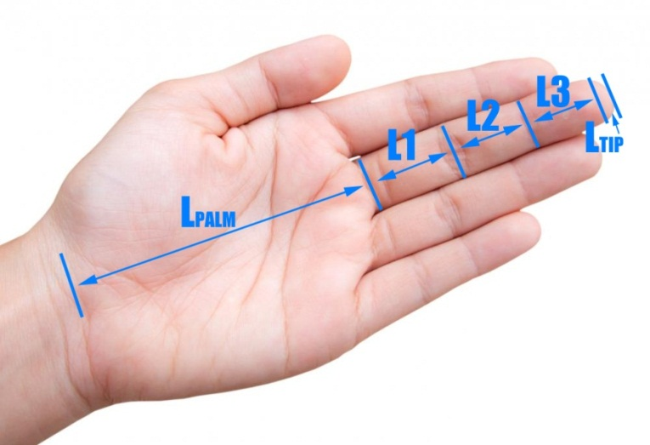

Figure 14: Hand showing finger lengths (all finger lengths refer to the middle finger).

Weight of the hand was determined as 425.7 grams, and weight of the hand and forearm was determined as 1,699.1 grams. It will be important to mimic the weight of a real hand and arm as closely as possible, to prevent discomfort. Finally, it was determined that the hand would be modeled first as having all middle fingers (this is because the middle finger is the longest finger and therefore made a good starting point to model), but that, time allowing, adjustments could be made to maintain accurate finger length ratios. The finger length ratios were found to be: index:middle=0.8, ring:middle=0.93, and pinky:middle=0.74. All of these derivations and the sources can be found in Appendix 2.

# Features and Comparisons of Conceptual Designs

These designs, once generated, were then compared via decision matrices to see which would be the most effective solutions. This would ensure that the best solutions could be selected and that the design could move forward from conceptual design into a stage in which testing and further research could be done.

First to be considered was the joint locomotion. Pneumatic muscles would most accurately mimic the way that a real human arm works, but are also fairly complex, expensive, and possibly difficult to control (since no group members has prior practical experience with pneumatics, learning control methods in addition to doing them may be difficult).

Motors at each joint would have had a full range of motion on each finger joint (to the point that they could easily drive the joint into itself—a distinct disadvantage) but they would also be expensive, bulky, and very complex (in order to control the hand it would be necessary to keep track of about 30 different motors).

The cable-and-motor setup would be relatively simple (turn a motor to effectively shorten a cable, drawing a finger in towards the palm), inexpensive (up to five motors would be required to run the fingers—a substantial improvement over 30), small, since the cables take up a negligible amount of space and the motors can be housed where there is more space in the forearm, and achieve a fairly accurate range of motion—the only problem being that a human can lock two joints and move just one (such as when typing or playing the piano), and the cables would all move fingers uniformly.

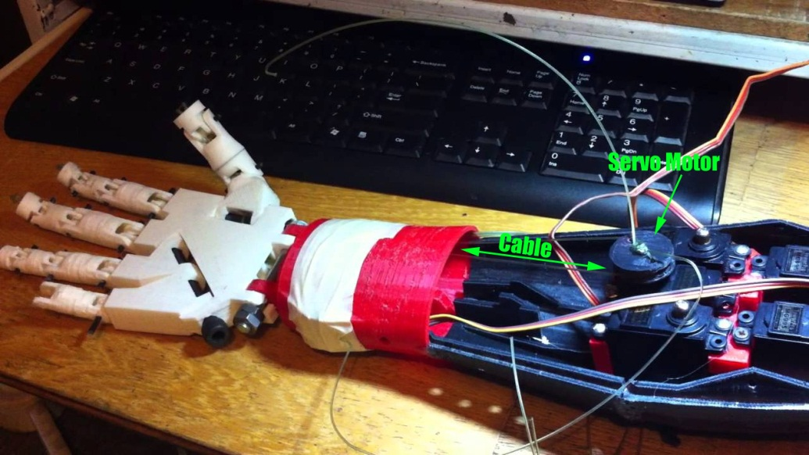

Figure 15: An existing hand design demonstrating the cable-and-motor motion system.

The idea of combining a motor at the base of the finger with cables running along its length was also considered. This base motor could correct the locking-joints problem (by just moving the base of the finger) but the added expense, bulk and complexity (because moving the first joint effectively shortens the cable, the cable motor would have to run backwards to accommodate the finger base motor whenever base motion was required) which made this solution less than worthwhile. Below is the decision matrix for all of the options considered.

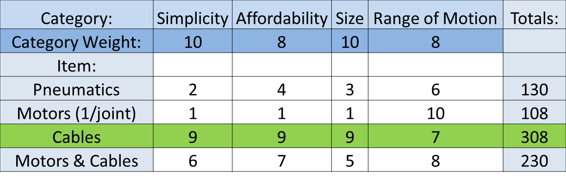

Figure 16: Joint motion decision matrix.

From the joint motion matrix, it was concluded that the cables were the most suitable option, reducing complexity and modeling the design after a proven technology. However, using cabling for joint motion opens up a number of other possibilities. Specifics about cabling design were then considered, namely the possibility of including one cable for every finger, sharing a cable between the ring and pinky fingers, having one cable per joint in the hand, and having one cable per every two joints in the hand. Having one cable per finger is fairly self-explanatory. Each finger is capable of independent control via a motor in the forearm. Combining the ring and pinky fingers onto one motor would decrease complexity without sacrificing much usability (since the two fingers are actually linked in a human hand). One cable per joint would allow the fingers to “wrap around” objects more efficiently, since the one cable per finger method would just cause the fingers to move uniformly in a C-shape, and one cable per two joints would achieve the same as one cable per joint whilst being less complex (and a little less effective). Ultimately however it was concluded that the grip improvement of the granular jamming pads would more than make up for the C-shape of a single-cable finger, and that having five cables was not so much more complex or expensive than having four that it was worth eliminating one. The decision matrix for this design is shown below:

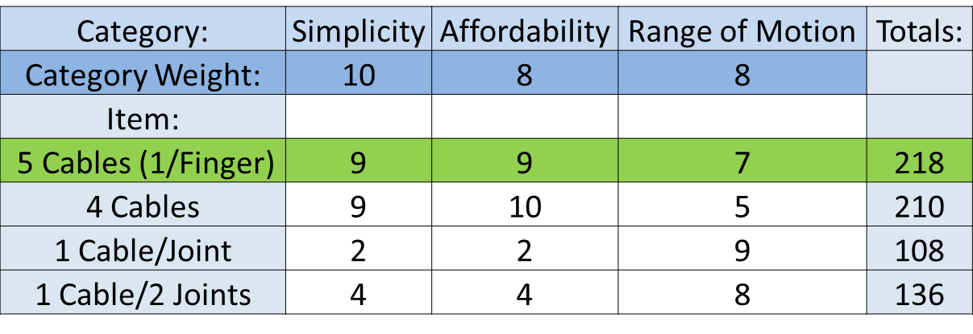

Figure 17: Cabling ideas decision matrix.

However, after the team’s phase one presentation, one panel member made the point that only three points of contact are required for most daily activities. Because of this, the four cable design is currently being reconsidered, as it would decrease some complexity and would not create much loss in usability (since the most commonly used fingers are the thumb, index, and middle finger).

Straightening the hand was an important consideration because the hand would not have a resting state like a human hand does with cable-controlled joints. Instead it would move around loosely as the arm was moved, making it difficult to position the fingers in useful ways. As a result, it was decided that the resting state of the fingers should be straight. The four methods considered to straighten the hand were large elastics, small elastics, flat springs, and a second set of cables. The large elastics would keep the hand straight, but would also incapacitate the entire finger if they snapped, and every time one broke it would be necessary to replace it by threading it back through its housing. Small elastics help to negate this problem by only being at the joints. If one small elastic snaps, only that joint is incapacitated. They would also be simpler to replace. Flat springs would require less design work, since elastics require plastic outcroppings to keep from hyperextending the fingers, and would be much more reliable than elastics. However, they would also be harder to repair and more expensive. A second set of cables would allow for hyperflexion when appropriate (and would keep the hand straight when not) but they would also double the number of motors necessary to run the hand, adding significant complexity and cost. The decision matrix for hand straightening ideas is shown below:

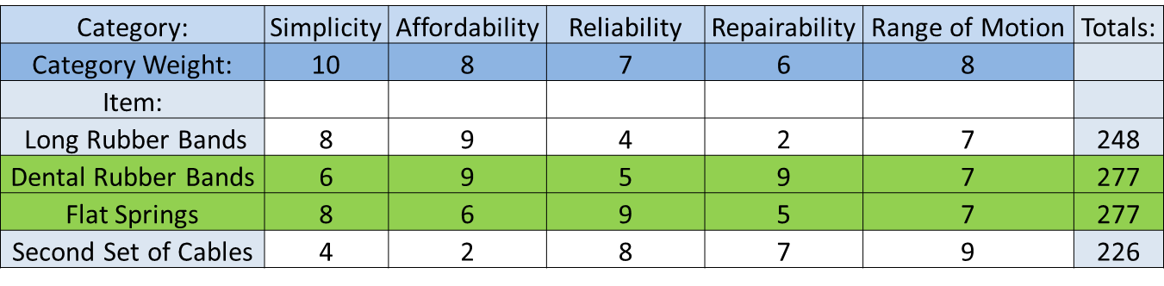

Figure 18: Straightening ideas. Both the dental rubber bands and flat springs proved to be reasonable solutions, so both will be tested (time allowing).

The final consideration for hand mechanics was grip sense. This would sense when the hand has come in contact with an object and can stop closing. The three options considered were user controlled button, bump sensors under the granular jamming pads, and encoders on the servos that could communicate when a motor was stalled (something that would occur when it had collided with an object and could no longer move). The user button, while the simplest and most inexpensive solution, was rejected because it assumed the user had use of their other arm. Bump sensors, conversely, were too expensive and complex to be feasible for this project. The number of required sensors would have to be tested, as well as how many would need to be engaged for a proper hold. Being electronic, they would prevent the hand from being waterproof (which, with the cabling system, it would be, since it requires no electronic components in the hand itself—only in the forearm), not to mention the added expense of up to 30 sensors (if it is determined that one should be placed in each joint). The encoders were selected as the most suitable choice. They were chosen, in part, because encoders would likely be necessary to find accurate finger positions, so they would not add significant expense (and only the same number of encoders as motors would need to be purchased, rather than a variable number, as with the bump sensors). The grip sense decision matrix can be seen below.

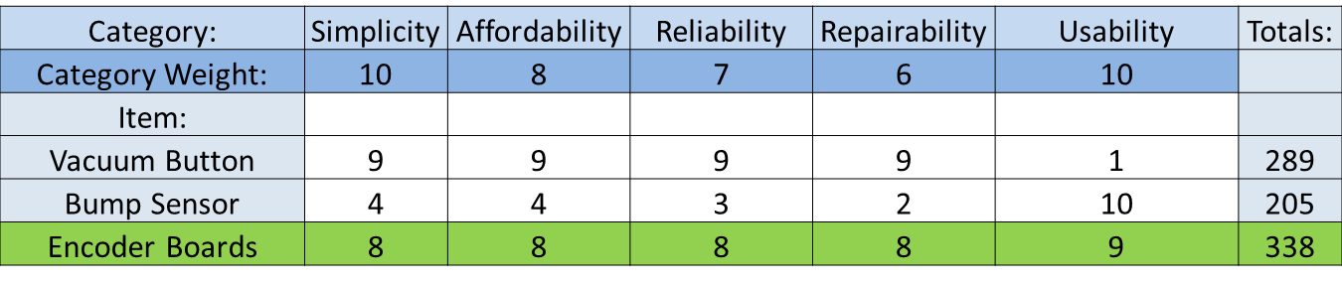

Figure 19: Grip sense decision matrix.

For the granular jamming pads, decision matrices were created on the basis of material, housing, and layout/control of the pads. The first component considered was granular material to be used in the pads. The materials the group considered are sand, coffee grounds, and plastic stuffing materials. All three materials are inexpensive, but each has its own drawbacks. Sand is heavy, coffee grounds may spoil, and plastic stuffing materials may be too large for finger tips. Therefore it was concluded that the team needs to do more investigation into what material to use.

The next component to consider was the housing material. Materials considered were balloons and silicone. Balloons were an inexpensive choice, but they are not durable or easy to cut into irregular shapes. Silicone was a more expensive option, but was also more durable and can be cast into any shape desired.

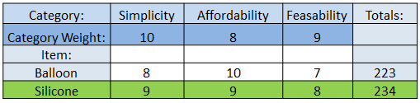

Figure 20: Materials decision matrix.

The final component to consider is the layout of the pads. The pads could either be interconnected or each individually attached to the vacuum. The advantage of having individual attachments is greater control over which pads would be activated during a grip. The downside to this is that it is a control nightmare and makes it very difficult to control properly. A simpler and effective solution is to have pads interconnected and all jam simultaneously when the vacuum is activated.

The number of pads to be used was then considered. Pads could either be on only the fingertip, the tip and the base, or the tip, base, and midsection of the fingers. The higher the number of pads per finger, the better the ability to grasp, but also the higher the complexity of the pad control. To help visualize appropriate placement of pads, the group decided to do some preliminary testing. This was done by coating household objects with chalk, grasping the object with a hand, and observing where the chalk stuck to the hand.

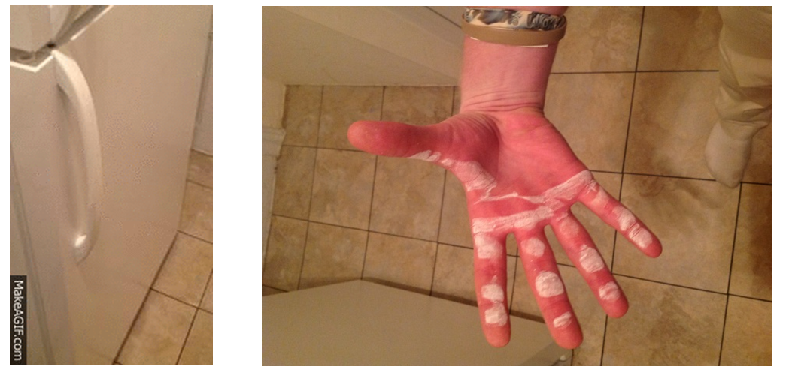

Figure 21: Example of preliminary testing using a refrigerator door handle. Additional examples of preliminary testing can be found in Appendix 3.

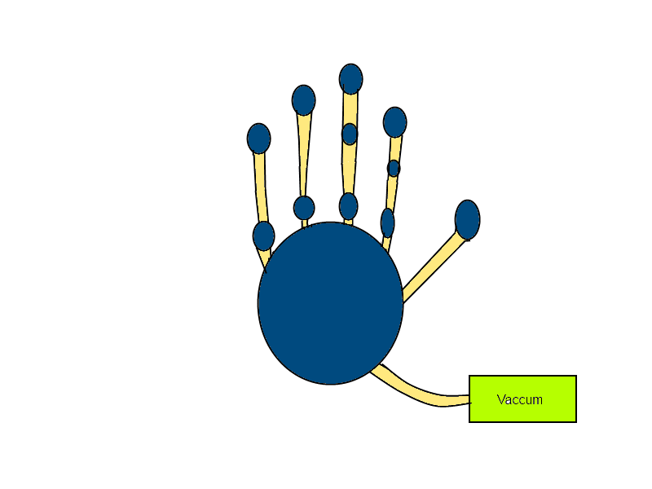Initially a layout with three pads on the most active fingers and two pads on each of the inactive fingers was selected. This was because all preliminary testing showed that the thumb, index, and middle fingers were the most actively used during the kinds of grips that were being tested. However after speaking with the panel during Phase 1 presentations, one professor made the good point that it is unnecessary to complicate the hand with additional granular jamming pads when most of our grips showed only three points of contact. Therefore it was decided that the granular jamming pads on the three active fingers and palm would be maintained, but the pads on the ring and pinky would be replaced with a high-friction material instead. This can be seen in the figure below, where blue areas are pads of the device, orange areas are high friction material, and yellow areas are connection medium. This gave a good balance between functionality and simplicity.

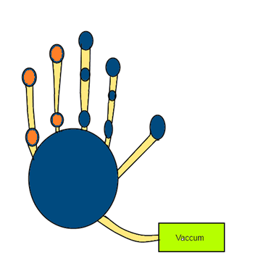

Figure 22: Left is the original design during Phase 1 presentations. Right is the improved hand design.

At the first presentation, the panel also recommended to reduce the total number of pads to simplify control. The group will take this into consideration and investigate the number of points of contact needed to hold an object and how much force is needed to hold an object in a hand, and explore possibly removing more of the granular jamming pads on the index and middle fingers.

# Technical Analysis and Engineering Design

The most predominant aspect that our project has to focus on is the movement of the right hand. Hands have three degrees of freedom: supination/pronation, extension/flexion and ulnar deviation/radial deviation.

[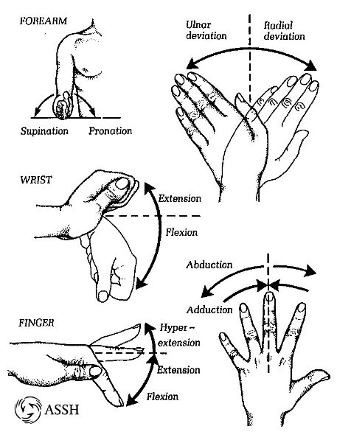](http://www.google.com/url?sa=i&rct=j&q=&esrc=s&frm=1&source=images&cd=&cad=rja&docid=ts9CQ3WJn00fSM&tbnid=-PQKcGkwnI4GOM:&ved=0CAUQjRw&url=http://www.assh.org/Public/HandAnatomy/&ei=9AVAUv_mFvO-4APxsoDoCw&bvm=bv.52434380,d.dmg&psig=AFQjCNER24arUQF3ekTWh0GkXqXRcPqARQ&ust=1380013844177859)

Figure 23: Hand motions.

The granular jamming prosthetic hand will mimic the hand movements that are required to grab an object or twist, for example, a door knob. To do that, the hand will need small motors to generate force, sensors to tell when to grab or let go of an object, and the granular jamming system to insure the firmness of the grabbing motion.

[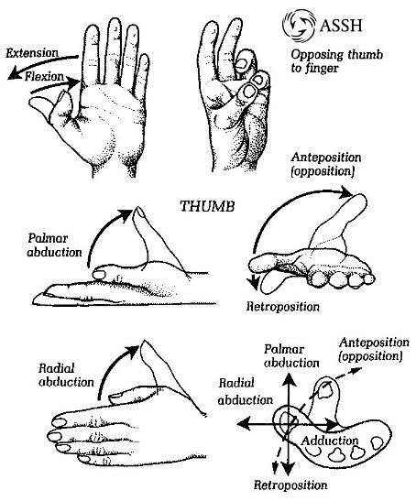](http://www.google.com/url?sa=i&rct=j&q=&esrc=s&frm=1&source=images&cd=&cad=rja&docid=ts9CQ3WJn00fSM&tbnid=7lPJ9ZDU6kJcMM:&ved=0CAUQjRw&url=http://www.assh.org/Public/HandAnatomy/&ei=VQlAUuaBGMWn4APVt4DgBQ&bvm=bv.52434380,d.dmg&psig=AFQjCNGcUe3CYv9HTXhqloem4mL2xRfUug&ust=1380014791067707)

Figure 24: Additional hand motions.

The number of motors required to generate extension/flexion, palmar abduction and twist is to be determined. The prosthetic hand needs five motors to control five fingers (unless the four motor solution is chosen). One motor is needed for every finger, one for solely for twisting motion (if it is included) and possibly a seventh motor for the vacuuming granular jamming system. Thus, the prosthetic hand will require at least five motors, but up to seven. The 3D printable prosthetic hand will not be able to lift very heavy things, but it will have high functionality. It will be able to open various kinds of door knobs, grab an object and control the fingers. Since the hand is going to be constructed with 3D printable plastics, the team will need to know how much heat, torque and pressure the hand can withstand. The analysis will be done in *SolidWorks*.

The granular jamming system in the prosthetic hand needs reliable fabrication for the outer layer that holds the granular jamming particles inside the pads. The prosthetic hand will need to be used on an everyday basis. Fabrication and reliability are very important. It must be water resistant as well as wear resistant. Thus, we will perform physical tests with silicone and various granular jamming materials (coffee grounds, bead stuffing, etc) to determine reliability.

The hand will have essentially one degree of freedom. Each cable will control one finger that will have curling motion. The primary objective is to have a curling motion. If the curling motion is complete, then a twisting motion (such as that of the wrist) will be added if time allows. In that case, the hand will have two degrees of freedom.

The hand will be cyclically built, tested and refined, which is called iterative development. Friction, wear, and fabrication of various materials used in making granular jamming pads will be evaluated.

The governing equations for the hand will be:

Friction Force: $F_{r}=μN$

Calculation for time for vacuuming certain volume V given volume flow rate capacity q between atmospheric pressure and inside of granular jamming housing: $t=\frac{V}{q}ln⁡(\frac{p_{0}}{p_{1}})$

The exact pressure needed to get all the air out is not yet determined, but “A Positive Pressure Universal Gripper Based on the Jamming of Granular Material” shows that about -85 kPa is appropriate.

Once the concept is finalized, the team can easily begin to build the model with SCAD or *SolidWorks* to study the movements of the prosthetic hand as well as material analysis. Also, the input codes for the encoder will be used to judge finger position. The goal is to test and optimize the duration of activating the motors as well as the vacuum. That way, motion controlling motors, granular jamming systems and sensors will be integrated as we expect.

# Deliverables for End of Semester

The team came together and set several goals for the end of the semester. By mid-December, they will have prepared a complete hand design, ready to be prototyped in the spring. Throughout the semester technical analysis will be continued to keep the project moving forward, in the form of computer modeling, physical testing, and calculation. The team will continue to do research, gaining significant knowledge in the materials, robotics and biomechanical fields. As this material is learned, they will constantly improve on the design, revisiting old decisions and possibly changing them.

Project designs and interfaces will be tested with hands-on experiments. Members of the group will become fluent using OpenSCAD to finalize design and complete the prototype for the spring semester. By the end of the semester the group will also have finalized a bill of materials and created a fully functional website.

## Expected Budget

|  |  |  |  |
| --- | --- | --- | --- |
| Part | Quantity | Cost | Total |
| dyIO | 1 | 75.00 | $75.00 |
| Polycarbonate 3mm Filament | 1 | 74.99 | $74.99 |
| Natural ABS 3mm Filament | 1 | 37.95 | $37.95 |
| 10 piece rotary encoder set | 1 | 10.00 | $10 |
| Servo Motor | 7 | 8.95 | $62.65 |
| 25 1/4th inch stainless steel screws | 1 | 6.49 | $6.49 |
| 30 pack Small Ball Bearings | 1 | 14.95 | $14.95 |
| 30 bag 5/16" rubber bands | 1 | 4.95 | $4.95 |
| VEX Robotics NiMH Robot Battery | 1 | 19.99 | $19.99 |
| 6' Silicone Air Line Tubing | 1 | 3.33 | $3.33 |
| 1 pint Platex Mold Latex | 1 | 36.00 | $36.00 |
| Detailed Plastic Acrylic based | 5 | 2.99 | $14.95 |
| Air Pincette Vacuum Tweezers | 1 | 75.00 | $75.00 |
| Total Price |  |  | $436.25 |

## Project Schedule

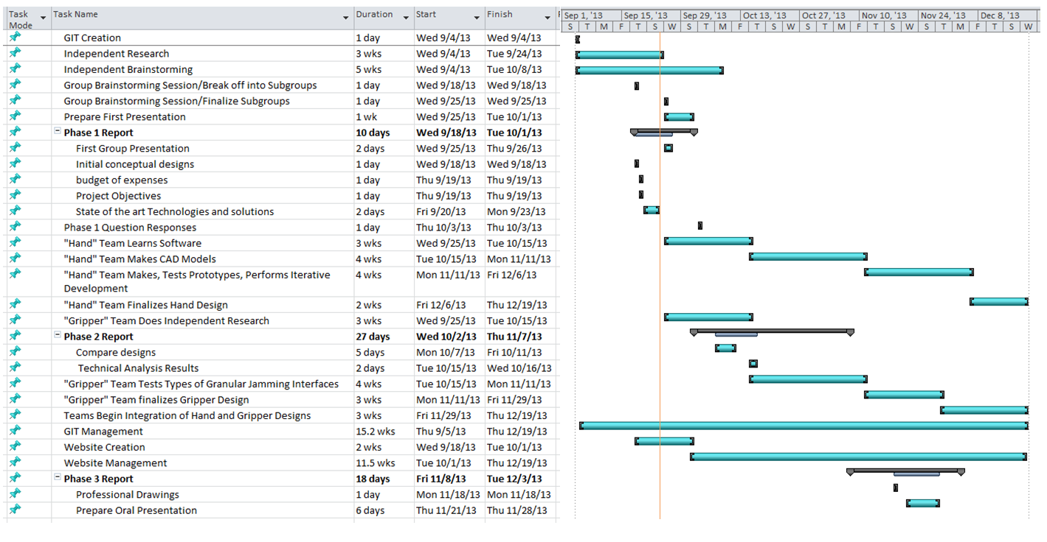

# Summary and Conclusion

The group has conceptualized and started planning the creation of a mechanical hand to be used primarily as a prosthetic. This hand is being designed with the intention to be easily available to amputees around the world. Cost and weight will be low thanks to the open source nature of the project and its method of manufacture, 3-D printing. Then hand is intended for everyday use for low strength and high dexterity functions. Motion of fingers will be driven by servo motors, and the gripping capabilities of the fingers and palm will be supplemented by use of granular jamming pads.

The prosthetic hand with granular jamming serves better functionality. For instance, one can have better grip, new kind of grip, low cost, widespread availability and customization. It is going to be unique in a sense that the prosthetic forearm with granular jamming can enable patients to be sure of the grip and comfortable using it. Slippery surfaces and small objects are the ones to fall off the hand if control system is not extra-accurate. The technology of mixing controlling five hands with granular jamming is much better.

Controlling itself is going to be a challenge. However, with granular jamming, it is going to be relatively doable. For example, you can activate motors first. Then, motors will send signals to tell where the position of fingers is. After that, if grip is done, motors are told to hold position. In that way, the patient is confident that grip is strong enough not to let go, unless he or she tells it to do so. There will be three joints per finger for better grip and control. The group considered having two joints or reducing the number of fingers. However, doing so makes the hand less functional and less dexterous.

All in all, the team has set a difficult challenge for itself, but has a good start and is headed for success.

# Nugget Chart

**Nugget Chart**

**3D Printed Granular Jamming Hand**

**Group:** Melissa Indoe, Chris Kang, Sean Phelan, Maggie Serra, Chris Wallace

**Advisor**: Professor Robert Chang **Project # 37 10/1/13**

|  |  |
| --- | --- |
| **Project Objectives** | **Conceptual Designs and Highlights** |
| The objective is create an open-source, affordable and high-functioning prosthetic hand. The Hand will be similar in size and weight to a human hand, looking similar as well. Primary tasks include picking up and putting down objects around the house and also openning different doors and knobs. The use of individual fingers is important too as another task set forward is pointing and computer mouse clicking. THe project also looks to incorporate granular jamming technology to help with grabbing and holding of objects for the user. | The team brainstormed several different ideas for the hand itself; how the joints would move, holding positions, straightening of the hand, and sensing grip. While for the moving joints pneumatics, motors and cabling systems were all also considered. The ascept of Granular jamming was also split into the material used, housing for the pads, and layout of the pads. The pads had to be strong enough not to shear after extensive use. |
|
|
|
|
|
|
|
|
| **Why this Project and State-of-the-art** |
| The Design project would have a huge significance and impact on society. With 12,500 amputations per year the design could look to improve the lives for those less fortunate financially. Current technologies used by companies such as RSLSteeper created hands that placed sensors on the skin to pick up impulses from muscle tissue. These hands optimize weight distribution and have individual finger speed. These hands cost $11,000 though and many of other top prosthetics have similar technologies but range from $74,000 to $100,000. The Robohand, a hand created by a factory worker, was a cheap prosthetic run by cables created on a 3D printer. The team looks to take the Robohand idea while incorporating granular jamming |
|
|
|
| **Drawing and Illustration of Promising Concepts** |
| - Cable Through Finger Design -Rubber bands at Joints for finger    -Springs at finger Joints -Granular Jamming Pads |
|
|
|
|
|
|
| **What Are the Key Areas/Ascepts to Solve** |
| The key aspects of the of the project involve creating the cheap prosthetic arm while incorporating granular jamming. The design needs to be sophisticated to involve the control over fingers and jamming pads while also being simple enough to be created by any user with 3D printer access. For the final product to be used in wartorn countries the design needs to stay simplistic. |
|
|
|
|
|

# References

Alexander, Buryanov, and Kotiuk Viktor. "Proportions of Hand Segments." *Int. J. Morphol* 28.3 (2010): 755,-58. Web. <http://www.scielo.cl/pdf/ijmorphol/v28n3/art15.pdf>.

Amend, J.R., Jr., Brown, E., Rodenberg, N., Jaeger, H., Lipson, H., "A Positive Pressure Universal Gripper Based on the Jamming of Granular Material," IEEE Transactions on Robotics, vol. 28, pp. 341-350, Apr. 2012.

"Average Hand." *The Average Body.com*. TheAverageBody.com, 2012. Web. <http://www.theaveragebody.com/average_hand_size.php>.

Biroli, Giulio. "Jamming: A New Kind of Phase Transition?" *Nature Physics* 3 (2007): 222-23. *Nature.com*. Nature Physics. Web. <http://www.nature.com/nphys/journal/v3/n4/full/nphys580.html>.

Cheng, N.G.; Lobovsky, M.B.; Keating, S.J.; Setapen, A.M.; Gero, K.I.; Hosoi, A.E.; Iagnemma, K.D., "Design and Analysis of a Robust, Low-cost, Highly Articulated manipulator enabled by jamming of granular media," *Robotics and Automation (ICRA), 2012 IEEE International Conference on* , vol., no., pp.4328,4333, 14-18 May 2012  
< <http://ieeexplore.ieee.org/stamp/stamp.jsp?tp=&arnumber=6225373&isnumber=6224548>>

De Leva. "Body Segment Data." *Body Segment Data*. ExRx.net, 1996. Web. 01 Oct. 2013. <http://www.exrx.net/Kinesiology/Segments.html>.

"Features." *The Bebionic 3 Myoelectric Hand Product*. RSLSteeper, n.d. Web. <http://bebionic.com/the_hand/features>.

Freeland A, Psonak R. Traumatic Below-elbow Amputations.*ORTHOPEDICS.* 2007; 30: [[link]](http://www.healio.com/orthopedics/journals/ortho/%7Bd8543c5d-935b-46b7-bc35-482cb8921806%7D/traumatic-below-elbow-amputations)

"I-limb Ultra Revolution." *Touch Bionics News RSS*. Touch Bionics, 2013. Web. <http://www.touchbionics.com/products/active-prostheses/i-limb-ultra-revolution/>.

"The Journey." *Robohand Customised, Fitted, Mechanical Fingers and Hands*. Robohand, n.d. Web. <http://robohand.net/the-journey/>.

Kulley, Marlowe. "Statistics." *Biomed.brown.edu*. Brown University, n.d. Web. <http://biomed.brown.edu/Courses/BI108/BI108_2003_Groups/Hand_Prosthetics/stats.html>.

Langevin, Gael. "InMoov." *InMoov*. Gael Langevin, n.d. Web. <http://www.inmoov.fr/project/>.

"Michelangelo." *Ottobock  - Home*. Ottobock, n.d. Web. <http://www.living-with-michelangelo.com/gb/home/>.

LeBlanc, Maurice. ""Give Hope - Give a Hand" - The LN-4 Prosthetic Hand." Lecture. *Stanford.edu*. Stanford. Web. <http://www.healio.com/orthopedics/journals/ortho/{d8543c5d-935b-46b7-bc35-482cb8921806}/traumatic-below-elbow-amputations>.

McFadden, D., and E. Shubel. "Relative Lengths of Fingers and Toes in Human Males and Females." *Horm Behav* 42.4 (2002): 492-500. *PubMed*. U.S. National Library of Medicine. Web. <http://www.ncbi.nlm.nih.gov/pubmed/12488115>.

# Appendices

## Appendix 1: Granular Jamming Pictorial Explanation

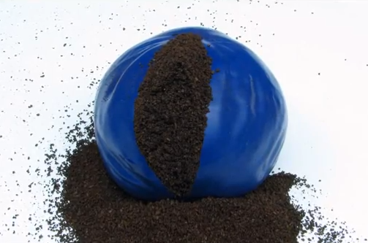 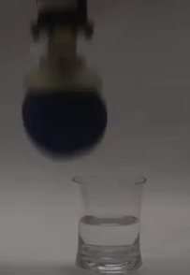

A flexible casing is filled with granules The casing is placed on the end of a robotic arm

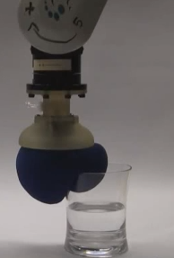 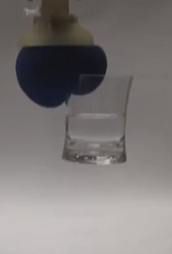

The casing is placed on an Now that the granules are rigid,

object and the air is removed. the robot can pick up the object

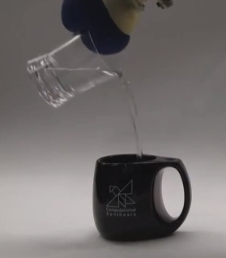 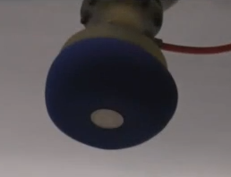

The object is held securely The robot can also do tasks that are difficult for humans, such as picking up a coin off of a flat surface

## Appendix 2: Goal size for prosthetic hand

**Overall Length:** 180.5 mm (wrist to longest finger)

**Overall Width:** 79mm (across widest part of palm)

**Finger Width** = (Palm Width)/4 = 19.75 mm

Source: <http://www.theaveragebody.com/average_hand_size.php>

(Values were obtained by averaging the average male and female hand size)

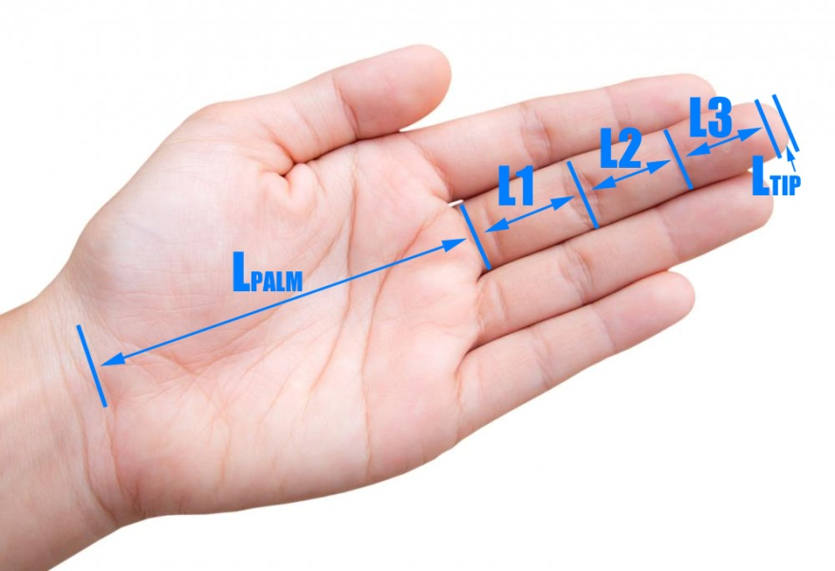**Hand Segment Lengths:**

**L1** = 44.63 mm

**L2** = 26.33 mm

**L3** = 17.4 mm

**Ltip** =3.95 mm

Lpalm = Overall Length – Length of Fingers

= 180.5-(L1+L2+L3+Ltip)

**Lpalm** = 88.19 mm

Source: “Proportions of Hand Segments”

Finger lengths above refer to segments of the middle finger. L1, L2 and L3 are lengths of finger segments (joint to joint), Ltip is the length of the padded part at the tip of the finger.

If you don’t want to make the fingers all the same length (something I might recommend trying after one prototype), then real fingers follow a ratio:

**Finger Length Ratios:**

**Index Length** = 0 .8*(Middle Length)

**Ring Length** = 0.93*(Middle Length)

**Pinky Length** = 0.74*(Middle Length)

Source: “Relative Lengths of Fingers and Toes in Human Males and Females” (also in this folder)

**Weight:**

**Weight of the hand** = 425.7 grams

**Weight of the hand & forearm** = 1,699.1 grams

It is just as important to keep the hand at a proper weight as it is to keep it at the proper size! A person with more weight on one side than the other will subconsciously lean to the side where they have less weight, cause long-term problems with their spine.

**Weight Calculations (to show where the weight values came from):**

Weight of the hand* = 0.575%

Weight of the hand & forearm* = 2.295%

*as expressed as percentage of total bodyweight

Source: <http://www.exrx.net/Kinesiology/Segments.html>

Average human weight: 74.035 kg

Source: <http://www.theaveragebody.com/average_weight.php>

(found by taking the average of all male values, then the average of all female values, and then the average of those averages.

Weight of the hand = (.00575)*(74.035) = .4257 kg = 425.7 grams

Weight of the hand & forearm = (.02295)*(74.035) = 1.6991 kg = 1,699.1 grams

## Appendix 3: Preliminary Testing with Chalk

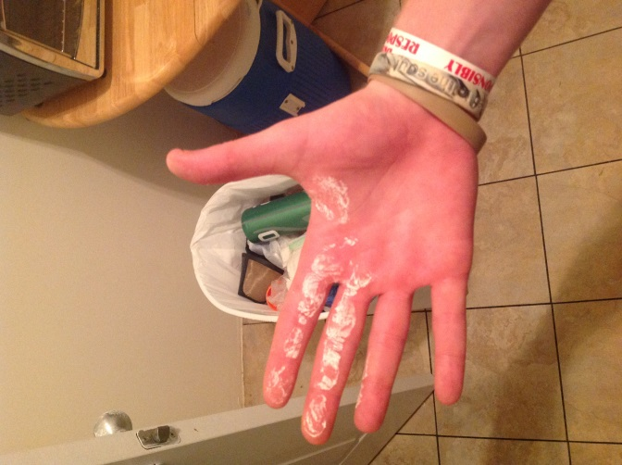

Hand after opening door knob. Chalk is on mainly the index and middle fingers, and the side of the palm.

 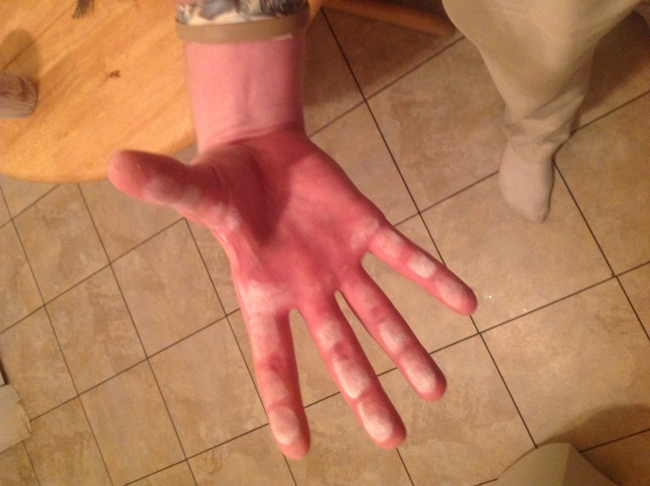

Hand after picking up cup. Chalk is fairly evenly distributed along the joints of the four fingers and thumb.

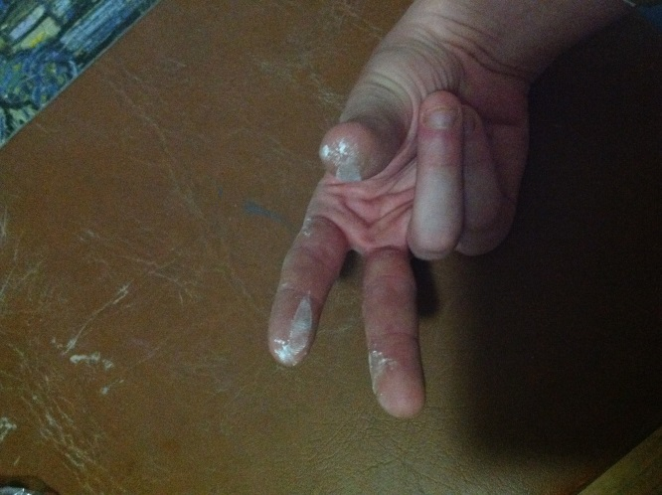

Hand after holding pencil. Chalk is on the thumb tip, the index finger tip, and the middle finger tip.